A PROJECT REPORT

ON

DETECTION OF EMPTY SEATS IN A LIBRARY.

B.TECH AIML-A

SUBMITTED BY- SUBMITTED TO -

NAMAN ARORA (00517711623) DR SRISHTI

ANSH GAUR (05017711623)

MANAV SAINI (05117711623)

ARUSH CHHALARIA (037117711623)

**PROJECT DESCRIPTION**

TITLE - DETECTION OF EMPTY SEATS IN CLASSROOM / LIBRARY.

SOFTWARE USED - Python, OpenCV, Numpy

SCREENSHOT

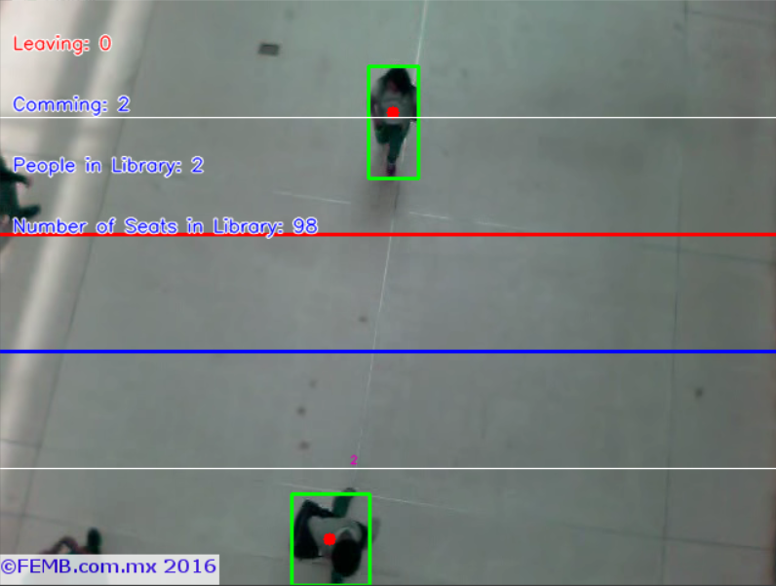

PROJECT DESCRIPTION –

The project focuses on detection of people entering and existing a library or classroom and subsequently detecting number of vacant seats available in the library.

The project is made using programming language python and OpenCV library.

The project works by the process of Object Tracking.

It works by identifying the contrast ratio between the floor and the object (people).

The floor is light coloured and the objects are dark which helps the code to identify people coming in and going out of a room

It then subtracts the people going in from the total number of seats and adding the people leaving to the total number to seats to show the number of available seats in the library.

APPLICATION-

It can be used in different places like libraries, parking lots, cafeterias, and other places which experience high traffic and crowd and can show the information in advance to people trying to come to the desired place and avoid queues.

SOFTWARE MODELS-

Source Code:

<https://github.com/naman22a/library-people-detection>

Video Link: <https://drive.google.com/file/d/1nvALoKbj8ZXhPgqmykWgjijGYT-kIuUw/view?usp=sharing>